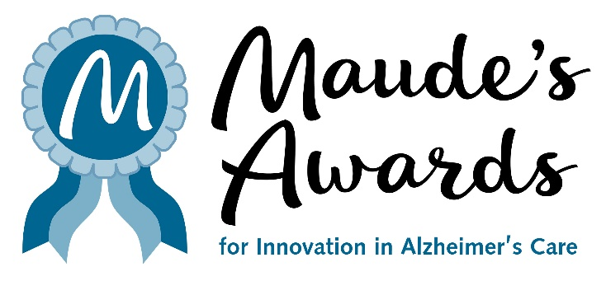

FOR IMMEDIATE RELEASE
MARCH 14, 2025
Media Contact: Julie Furlong, 206.850.9448, juliefurlong@comcast.net

MAUDE’S AWARDS CONTINUES TO ENRICH LIVES
MAUDE’S AWARDS RECOGNIZE AND REWARD INNOVATIVE CARE
FOR PERSONS LIVING WITH ALZHEIMER’S DISEASE

AWARD APPLICATIONS OPEN TODAY!

SEATTLE, WA – Maude’s Awards applications for Innovation in Alzheimer’s Care open today and are now available at www.MaudesAwards.org.

Maude’s Awards was developed to gather and share innovations that will enrich the quality of life for persons living with Alzheimer’s disease and related dementias and their care partners.

Maude’s Awards annually makes up to eight awards – three $25,000 awards to organizations and up to five $5,000 awards to individuals – for existing innovations that have demonstrated success in one of four categories of care (Making Connections, Cultivating Health, Supporting Care Partners and Treating By Design - see https://maudesawards.org/the-awards/).

-----------------------

Examples of previous recipients’ successes since winning a Maude’s Award:

LORETTA VENEY – Loretta Veney Inspires Memories Using LEGO Serious Play (2023)
“Since winning a Maude Award in 2023, I have shared LEGO Serious Play (LSP) with more than 800 individuals with dementia and family and professional caregivers! Helping organizations and families build Brick Memories using LEGO bricks allows me to carry on my mom Doris' memory and Maude's legacy of finding innovative ways to engage with those with dementia. At the end of 2023 I also began training those in the senior living and health care fields to become certified LSP facilitators so they too can bring the joy of LEGO Serious Play to thousands of others!”

JEWISH FAMILY AND CHILDREN’S SERVICE MEMORY CAFÉ PERCOLATOR (2022)
The EMC2 project (Expanding Memory Cafes, Enhancing Meaningful Connections) completed its goal of creating a plan to grow Memory Cafes tenfold in the US.

The plan launched in October 2024 at the Grantmakers in Aging meeting. EMC2 has officially transformed into the Memory Cafe Alliance (MCA); trademark pending.

This decentralized alliance is housed at Dementia Friendly America, also home to the new memorycafedirectory.com, and three free training modules serving a national training system (expected March, 2025, supported by the Brookdale Foundation). MCA now seeks support for a two-year effort to establish a Train-the-Trainer program and launch a national public awareness campaign.

-----------------------

The 2024 Awards Recipients were announced in October and can be found here - 2024 Awardees – Maude's Awards.

In 2019, Richard Ferry founded Maude’s Awards for Innovation in Alzheimer’s Care, inspired by Maude, his beloved wife of 65 years. She lived her life with grace and elegance, a beacon of hope, love, wisdom for all who knew her. She was and will always remain the wind beneath his wings.

Maude developed dementia in 2013 and Richard became her loving care partner, always searching for ways to bring joy and happiness to her life. His search led him to create Maude’s Awards, dedicated to the discovery and celebration of programs and practices of care that are enriching the lives of people living with dementia, and their care partners, and sharing these programs with the wider Alzheimer’s care community.

For more information about Maude’s Awards and to access the Awards Application, visit www.MaudesAwards.org. Applications will be accepted through May 19 at 6pm PST.

Follow us!

Facebook: https://www.facebook.com/maudesawards/
Instagram: https://www.instagram.com/maudesawards/
LinkedIn: http://linkedin.com/company/maudes-awards/
Twitter: https://twitter.com/maudesawards

