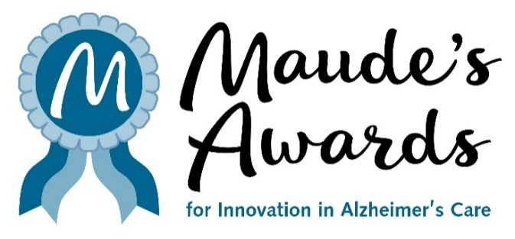

FOR IMMEDIATE RELEASE
MARCH 9, 2026
Media Contact: Julie Furlong, 206.850.9448, juliefurlong@comcast.net

MAUDE’S AWARDS CONTINUES TO
GATHER INNOVATIONS TO ENRICH LIVES
MAUDE’S AWARDS RECOGNIZE, REWARD AND SHARE INNOVATIVE CARE
FOR PERSONS LIVING WITH ALZHEIMER’S DISEASE

AWARD APPLICATIONS OPEN ON
FRIDAY, MARCH 13

SEATTLE, WA – Friday the 13th brings good luck for a change! Maude’s Awards applications for Innovation in Alzheimer’s Care open on March 13 and will be available at www.MaudesAwards.org.

Maude’s Awards was developed to gather and share innovations that will enrich the quality of life for persons living with Alzheimer’s disease and related dementias and their care partners.

Maude’s Awards annually makes up to eight awards – three $25,000 awards to organizations and up to five $5,000 awards to individuals – for existing innovations that have demonstrated success in one of four categories of care (Making Connections, Cultivating Health, Supporting Care Partners and Treating By Design - see https://maudesawards.org/the-awards/).

In 2019, Richard Ferry founded Maude’s Awards for Innovation in Alzheimer’s Care, inspired by Maude, his beloved wife of 65 years. She lived her life with grace and elegance, a beacon of hope, love, wisdom for all who knew her. She was and will always remain the wind beneath his wings.

Maude developed dementia in 2013 and Richard became her loving care partner, always searching for ways to bring joy and happiness to her life. His search led him to create Maude’s Awards, dedicated to the discovery and celebration of programs and practices of care that are enriching the lives of people living with dementia, and their care partners, and sharing these programs with the wider Alzheimer’s care community.

-----------------------

Examples of previous recipients’ successes since winning a Maude’s Award:

Hailey Richman (2022)
“Since receiving the Maude's Award, I am proud to share that Puzzles To Remember, my youth-led organization has, so far, donated in excess of 236,000 puzzles (valued at $2 million) to more than 5400 facilities including all 50 states and 16 countries. We have kept 148 tons of used puzzles out of landfills. Kid Caregivers - my nonprofit support forum is piloting a program to award high school students with community service hours for their caregiving responsibilities. We continue to offer peer-to-peer support for caregiving youth. In 2024, I received the Diana Legacy Award for having the largest youth-led Alzheimer's nonprofit. I was invited to London by HRH Prince William to receive the award, named in honor of his late mother. Additionally, in 2025, I received the Regeneron International Science and Engineering Fair (ISEF) Grand Award - 3rd Place for my research, along with the American Psychological Association (APA) Award for Excellence in research. I am a Freshman Research Immersion Scholar and am on the Dean's List.”

C. Nathaniel Brown (2024)
"Since being a Maude's Award recipient in 2024, I have been fortunate enough to continue the mission of spreading awareness around dementia's impact in the African American community, but also expanding the vision and mission in other areas. We established our nonprofit organization, Expose Dementia Inc., which utilizes the arts and media to educate about dementia and advocate for people living with dementia and their care partners. In March 2026, we will host our second Expose Dementia Conference with people from all over the country converging on Baltimore to connect, to learn, and to collaborate around the arts. The conference features a comedy show, an art exhibit, a film festival, and presentations from top dementia experts, including our keynote speaker, Teepa Snow. We are also developing new respite programs and kicking off our first community-based research study. We appreciate Maude's Awards for helping us establish a firm foundation for this vision."

I’M STILL HERE FOUNDATION (2022)
Since receiving a Maude’s Award in 2022, the I’m Still Here Foundation has significantly expanded its national impact by funding 27 new grantees who are implementing innovative, person-centered engagement programs for people living with dementia across community and cultural settings. Through these grants, strengthened partnerships, and growing field influence, the Foundation has continued to advance a hopeful model of care that emphasizes dignity, creativity, and meaningful participation. This momentum has been complemented by the continued leadership and recognition of founder Dr. John Zeisel, whose contributions were honored with the 2025 McKnight’s Pinnacle Thought Leader Award and the 2024 Lifetime Achievement Award from the International Academy for Design and Health. Together, these efforts have helped further shift the conversation around dementia from one of loss to one of possibility—reflected in the Foundation’s guiding vision of Hope in Action.

-----------------------

The 2025 Awards Recipients were announced in October and can be found here - 2025 Awardees – Maude's Awards

For more information about Maude’s Awards and to access the Awards Application, visit www.MaudesAwards.org. Applications will be accepted through May 19 at 6 p.m. PST.

Follow us!

Facebook: https://www.facebook.com/maudesawards/
Instagram: https://www.instagram.com/maudesawards/
LinkedIn: http://linkedin.com/company/maudes-awards/
Bluesky: https://bsky.app/profile/maudesawards.bsky.social

