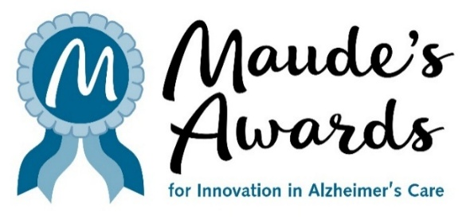

FOR IMMEDIATE RELEASE
APRIL 24, 2026
Media Contact: Julie Furlong, 206.850.9448, juliefurlong@comcast.net

ONLY THREE WEEKS LEFT TO SUBMIT
MAUDE’S AWARDS APPLICATIONS

MAUDE’S AWARDS RECOGNIZES, REWARDS AND SHARES INNOVATIONS IN CARE FOR ALZHEIMER’S DISEASE

SEATTLE, WA – There are only three weeks left to apply for a Maude’s Award, recognizing Innovation in Alzheimer’s Care. Applications are available at www.MaudesAwards.org and will be accepted through May 19 at 6 p.m. PST.

Maude’s Awards was developed to gather and share innovations that will enrich the quality of life for persons living with Alzheimer’s disease and related dementias and their care partners.

Maude’s Awards annually makes up to eight awards – three $25,000 awards to organizations and up to five $5,000 awards to individuals – for existing innovations that have demonstrated success in one of four categories of care (Making Connections, Cultivating Health, Supporting Care Partners and Treating By Design - see https://maudesawards.org/the-awards/).

In 2019, Richard Ferry founded Maude’s Awards inspired by Maude, his beloved wife of 65 years who developed dementia in 2013. Richard became her loving care partner, always searching for ways to bring joy and happiness to her life. His search led him to create Maude’s Awards, dedicated to the discovery and celebration of programs and practices of care that are enriching the lives of people living with dementia, and their care partners, and sharing these programs with the wider Alzheimer’s care community.

The 2025 Awards Recipients were announced in October and can be found here - 2025 Awardees – Maude's Awards

For more information about Maude’s Awards and to access the Awards Application, visit www.MaudesAwards.org. Applications will be accepted through May 19 at 6 p.m. PST.

Follow us!

Facebook: https://www.facebook.com/maudesawards/
Instagram: https://www.instagram.com/maudesawards/
LinkedIn: http://linkedin.com/company/maudes-awards/
Bluesky: https://bsky.app/profile/maudesawards.bsky.social

